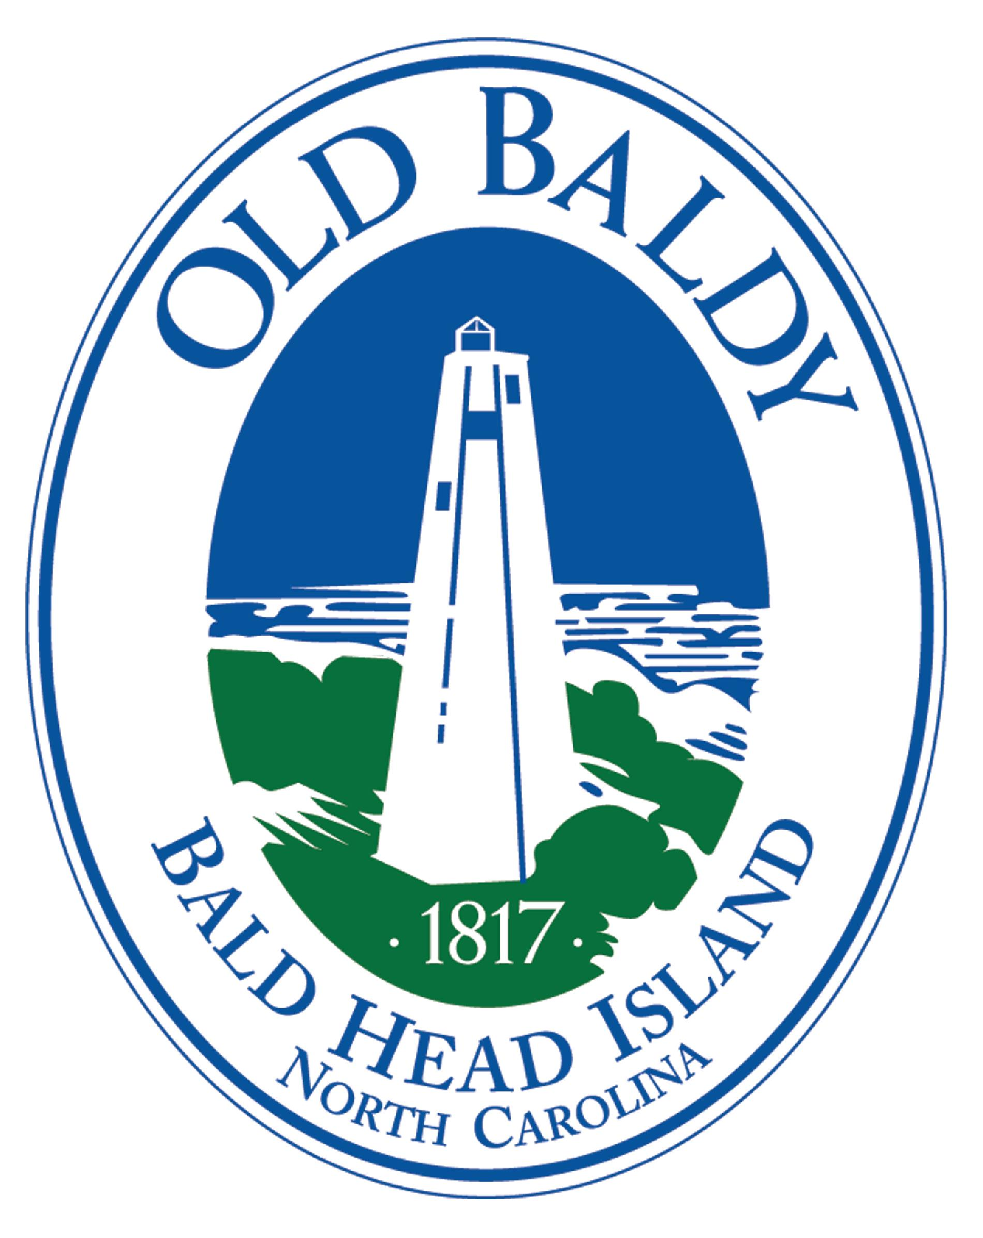
THE OLD BALDY FOUNDATION, INC.
5/19/25
And Smith Island Museum of History

Visitor Services Associate
(Part-Time, hourly, non-exempt position)

Position Summary:
Provides friendly, knowledgeable, and exceptional visitor service at the front desk of Old Baldy Lighthouse. This individual will operate the point-of-sale system, provide basic orientation information to visitors of Old Baldy Lighthouse, restock inventory in the museum store, provide light cleaning and restocking of the historic site’s facilities.
Reports to: Visitor and Museum Services Coordinator
Visitor Services
- Assist in daily business operations at the historic site, including the visitor services desk, museum store, and historic campus, with specific attention to opening, closing, and emergency procedures.
- Foster an enthusiastic team culture, emphasizing collaboration and creativity across departments, continuous improvement, and pride in the BHI community.
- Be an ambassador of the BHI community by anticipating common visitor questions and being knowledgeable of the island’s current events and logistics.
- Maintain a clean, safe, and presentable environment for all visitor-facing areas.
- Provide occasional logistical and visitor services support at programs and special events, which may include evenings and/or weekends.
Retail Services
- Operate Point of Sale System while following cash handling procedure.
- Assist in processing, organizing, and restocking museum store inventory
- Assists in maintaining the museum shop in a clean and attractive manner.

Qualifications

● Prior experience, or willingness to learn, Rain POS system.
● Physical demands typically associated with the position include but are not limited to light work, lifting, reaching, organizing, and moving inventory.
● Knowledge of or willingness to learn about the Cape Fear region’s historic significance.
● Flexibility to work evenings (private events) for special programming. Must work weekends and holidays as directed by the needs of the organization.
● All employees will comply with OBF’s policies and procedures.

The Foundation provides a welcoming and inclusive environment for visitors, volunteers and staff, and is proud to be an equal opportunity employer. All qualified applicants will receive consideration for employment. Please respond with resume and cover letter to director@oldbaldy.org

Ferry and Parking provided by the Old Baldy Foundation

